KEY DOCUMENT

DOCUMENT NO: ISSUE: 0.2

TITLE: Single Channel Monitor Box Engineering Design Specification

DOCUMENT TYPE: ENGINEERING PLAN AND DESIGN

APPROVED BY: DATE: FUNCTION:

Issue No. | 1 | 2
Date Issued | 10/01/2022 | 12/06/2022
Approved
Approved
Approved
Approved

DISTRIBUTION RECORD DOCUMENT NO:
Issue No. | Issued To | Department | Issue Date
1 | Project File Server | HB PC Engineering
2 | Project File Server | HB PC Engineering | 12/06/2022

REVISIONS DOCUMENT NO:
Change No. | Description | Date | New Issue
1 | Initial Version | 10/01/2022 | 1
2 | New Revision | 12/06/2022 | 2
3
4
5

CONTENTS
- INTRODUCTION
- RELATED DOCUMENTS
- OVERVIEW OF DESIGN
- MCU AND DEVELOPMENT ENVIRONMENT
- SOFTWARE MODULES
  - A/D CONVERSION FOR THERMOCOUPLE
  - TCP/IP STACK AND NETWORK INTERFACE
    - SETTING UP TCP/IP STACK
    - ADDING WEB SERVER INTERFACE
    - ADDING FTP SERVER
  - MCU AS MODBUS SERVER
  - USER INTERFACE
    - BUTTON HANDLER TASK
    - 7 SEGMENT TEMPERATURE DISPLAY
  - N.O. RELAY CIRCUIT
  - NON VOLATILE MEMORY
- CONCLUSION

1. INTRODUCTION
1.1 Background
The single channel monitor box is a low cost way to monitor the temperature of a FLEX heater. It works in series with a FLEX heater solution. It provides a simple three button interface to allow the customer to configure one setpoint. If the current temperature is greater than the setpoint, then that is considered normal. If it’s less than the setpoint, that will generate an alert. The device has a relay circuit that can inform another device of either a setpoint violation or loss of power.
The goal is to design a device that is easy to use, inexpensive, and accurate. Our competitors have such devices so we would also like to consider what these devices are like and to try to make something more desirable.
1.2 Scope
This document will cover the full design of the device by breaking it down into its parts. Every software module will be detailed, and wiring diagrams will be provided. This document should provide enough information that any developer could use it to design a prototype.
2. RELATED DOCUMENTS
Device datasheet for ATSAM4S family.
Single Channel Monitor Box Marketing Spec
Single Channel Monitor Box Scheduling Timeline
3. OVERVIEW OF DESIGN

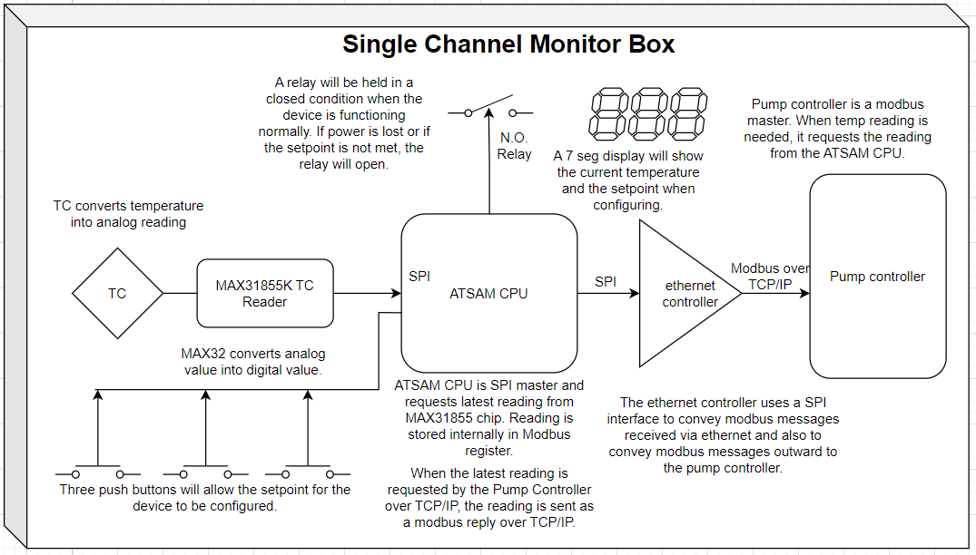The single channel monitor box will monitor a single thermocouple. Temperature readings are converted by a MAX31855K chip and received by the MCU via SPI. Readings are stored internally until a modbus master device requests them. The requests are received through an ethernet port that communicates modbus over TCP/IP. The monitor box acts as a modbus server, only storing the latest reading in an internal register.
Whatever the current temperature is, that is displayed on the device’s seven segment display. The device has only 1 setpoint that can be configured using the three push buttons provided. While configuring, the display will show the user the setpoint temperature as they are selecting it.
If the setpoint is violated (if the current reading is less than the setpoint), then a relay will open, allowing an interfacing device to be notified of the problem.
4. Mcu and Development environment
The microcontroller family selected for this project is the ATSAM4S family of microcontrollers. The full specs for this family are found in their device datasheet linked in the related documents section, but in summary, it is a 32 bit ARM Cortex-M4 processor with an internal clock speed of 120 MHz (ample speed for this application), with a good selection of peripherals and multiple packages ranging from 48 I/O pins and 100 I/O pins.
Here is a complete list of the specs for this MCU:
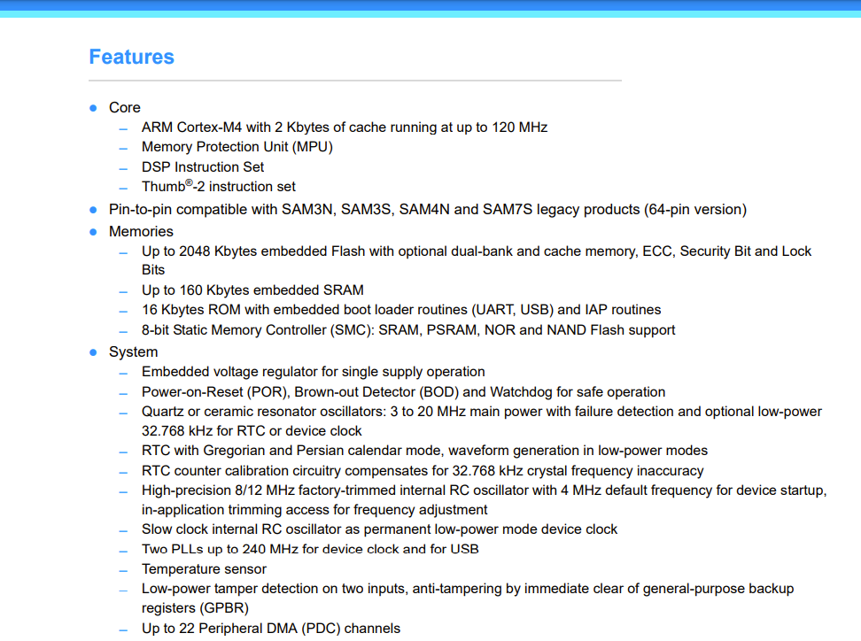
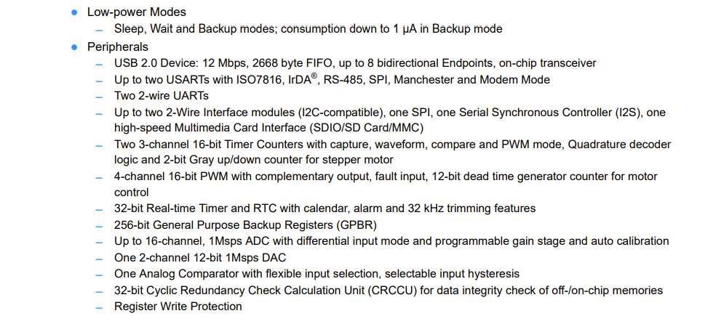
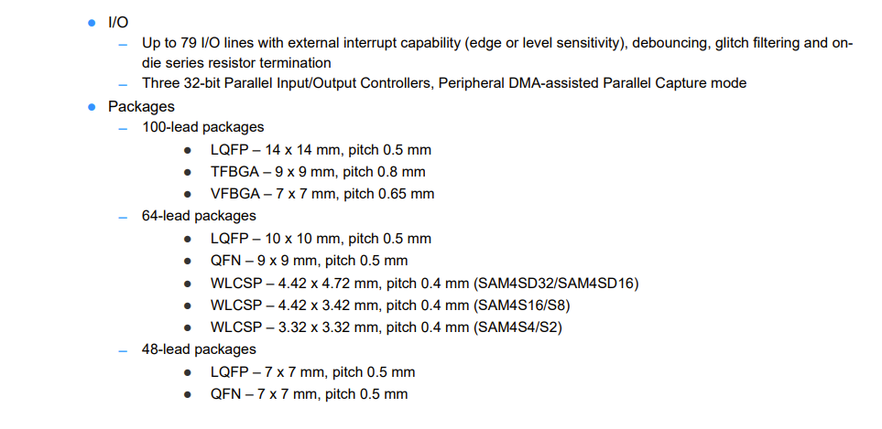
The development board selected for prototyping is the ATSAM4S Xplained Pro kit.
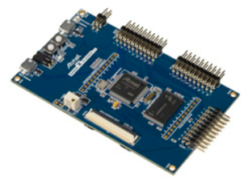
Here is a link to the product and its description. ATSAM4S Development Board
The integrated development environment this MCU uses is Microchip studio (formerly Atmel Studio). The software itself will run in a FreeRTOS operating system. The software will be written in C and debugging is easily accomplished over USB with Microchip studio. The development board comes preloaded with a debugging module that makes the process very simple. The ASF wizard in Microchip studio can be used to setup FreeRTOS and many of the low level drivers like the Power Management Controller and SPI.

5. SOFTWARE MODULES
5.1. TEMPERATURE READING WITH MAX31855K
The MAX31855 chip provides a convenient method to read temperatures using a thermocouple. This chip comes in different varieties to suit different types of thermocouples. Since this application will use type K thermocouples, the MAX31855K will be used.
Essentially, the chip handles all the complexity involved with cold junction compensation that normally has to be handled when reading thermocouples. The chip generates readings frequently and they only need to be clocked out by a master SPI device.
In this application, the MAX TC reader will be read once per millisecond for 2 whole seconds. All of the readings will be averaged to provide a software based noise filter. The temperature is read by asserting the devices chip select, clocking out the bits, and then interpreting the current temperature using the data format provided by the MAX31855 datasheet.
Once a temperature is averaged and calculated, it will be sent to other tasks for processing. For example the display driver will be a recipient since it will need to know what to display, and the setpoint handler will need it since it will always be monitoring the current temperature for an alert scenario.

5.2. TCP/IP STACK AND NETWORK INTERFACE
    - SETTING UP TCP/IP STACK
The ethernet module provides the hardware capability for an ethernet connection, but it also needs supporting software in FreeRTOS. This design will use the TCP/IP stack native to FreeRTOS, however there are other components to consider in the software framework. Here is a visual representation of the structure that needs to be implemented:
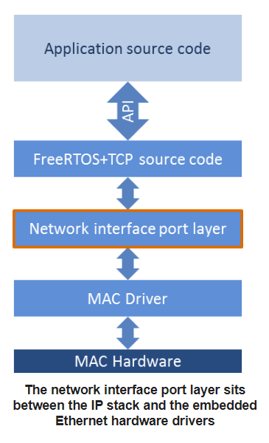
At the bottom of the stack is the ethernet chip itself. It is known as the MAC. On top of that is the MAC Driver. This is also known as the PHY or Physical Layer Transceiver. It provides the interface between the hardware and the network interface port layer.
In this application the PHY can be easily obtained from the ASF wizard in Microchip studio. Whatever ethernet chip is being used, ASF wizard can likely provide it as a component in the project. For the prototype, we are using the KSZ8851SNL which has a PHY driver available in ASF wizard.
If for some reason, the PHY is not provided in Microchip studio, then one can likely be located on Github. The worst case scenario is one would need to be written manually. This would simply consume time; it’s still very feasible.
The next layer is the network interface port layer. This essentially provides the glue that binds the TCP/IP stack to the PHY.
- The network interface port layer must provide a function called xNetworkInterfaceInitialise() that initializes the MAC driver.
- The network interface port layer must provide a function called xNetworkInterfaceOutput() that sends data received from the embedded TCP/IP stack to the Ethernet MAC driver for transmission.
- The network interface port layer must send packets received from the Ethernet MAC driver to the TCP/IP stack by calling xSendEventStructToIPTask().
What’s nice about the TCP/IP stack in FreeRTOS is it allows the code to be highly portable. The only code that would need to be changed in the event of changing ethernet chips is the PHY and the network interface port layer.
Here is a link to more information on setting up the TCP/IP stack and hardware interface:
Porting FreeRTOS-Plus-TCP to a Different Microcontroller
    - ADDING WEB SERVER INTERFACE
A requirement of the project is for the IP address to be configurable. In order to meet this requirement, the monitor box will host a local web server that will allow the IP address and other relevant network settings to be modified.
The host name of the server can be entered into any address bar and as long as there is a direct network connection between the monitor box and a host computer, then the web service will display the interface over http.
From a high level, the interface will be simple and allow for easy device customization.
From a design perspective, the web server functionality will be added by porting an existing example for the ATSAM4E line of devices. The main difference between ATSAM4E and ATSAM4S family of microcontrollers is that ATSAM4E has a built in MAC. Since we are adding an external MAC (the ethernet chip), this example should work on ATSAM4S, provided the TCP/IP stack is ported successfully.
Here is a link to the ATSAM4E http example (and other examples too).
FreeRTOS-Plus-TCP and FreeRTOS-Plus-FAT Examples
    - ADDING FTP SERVER
An FTP server will be implemented alongside the web server interface since it would be necessary to have a way to place the web resources onto the device. The ATSAM4E example mentioned above essentially bundles the web server with the ftp server since they are so similar. If that example is implemented correctly, then the FTP server will be added alongside the web interface without additional effort.
5.3. MCU AS MODBUS SERVER
A modbus server is a device that accepts commands from a modbus master. Modbus is an application layer protocol that sits on top of the TCP/IP stack.
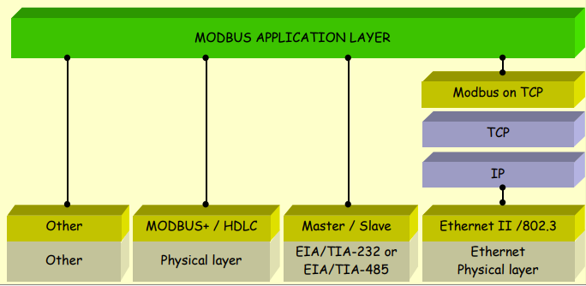
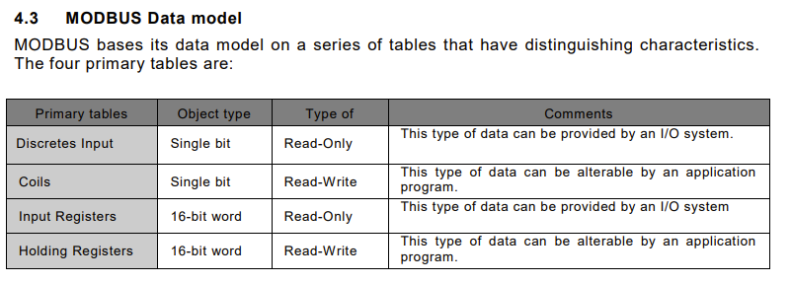
The best way to add modbus as an application layer protocol is to port an existing library that is tried and true. An excellent option is freeModbus. This library is made for embedded systems, it is well written, and is made for porting. They provide TCP implementations and RTU/ASCII. This could be useful for another project in the future that also uses modbus but not the TCP version. The code could easily be configured to work with TCP or Serial.
In order to add freemodbus to an application, one would download the library from their website. There is a port file that shows function stubs for functions that must be implemented. The only ones needed for the TCP port are labeled under the TCP section.
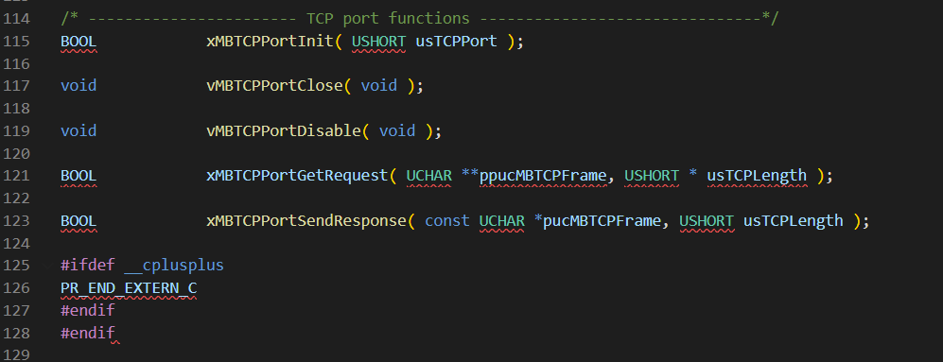

The xMBTCPPortInit function is responsible for launching a connection listening task. It’s only goal is to listen for clients. This task will also only handle one connection at a time so if a second client tries to connect, the current connection is severed.
The vMBTCPPortClose function completely closes down the modbus interface by killing any active connection and shutting down the listening socket.
The MBTCPPortDisable function will only shut down any active connection.
xMBTCPPortGetRequest is a function used to receive messages from the remote client. This function stub just provides a pointer for one to copy an address to. This address should point to the most recently received data along with the number of bytes. In the application, the connection instance will be responsible for reading data from the client and sending the address of the data over in a queue.
Then, once free modbus is fully implemented, it can be tested with a modbus master simulator like qModMaster. We use this for testing the TMS controller’s modbus interface.
The only additional work is to decide which input register should hold the current temperature. I will use 1000 for prototyping. If any other parameters should be available via modbus, we would just dedicate an input register, or holding register if the master is allowed to write, and keep it updated that way the values are always available.
5.4. USER INTERFACE
The user interface consists of three push buttons and 3 seven-segment display modules. There’s an up button, a down button, and a set button. The display modules always reflect the current temperature reading. The only other function of the display is to allow a single setpoint to be set. To change the setpoint, the set button should be pushed once. At this point, the display will slowly flash indicating that the setpoint may be adjusted. Pushing the set button again will save whatever setpoint they had selected using the up and down buttons. The device ceases to blink and shows the current temperature, signaling that normal operation has resumed.
5.4.1. BUTTON HANDLER TASK
An ISR will be used to monitor the input on the buttons asynchronously. Those inputs will be sent to a state machine task that will then send any requests to the control task, such as changing the display or updating a setpoint.
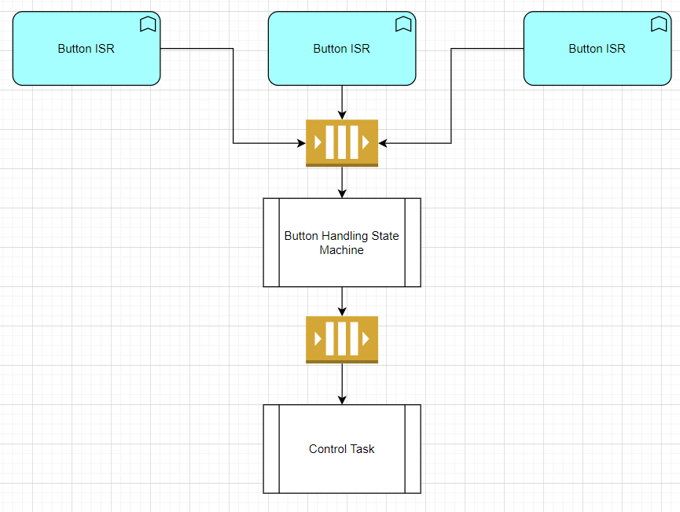
5.4.2. 7 SEGMENT TEMPERATURE DISPLAY
The display logic will follow a state machine behavior as outlined below:
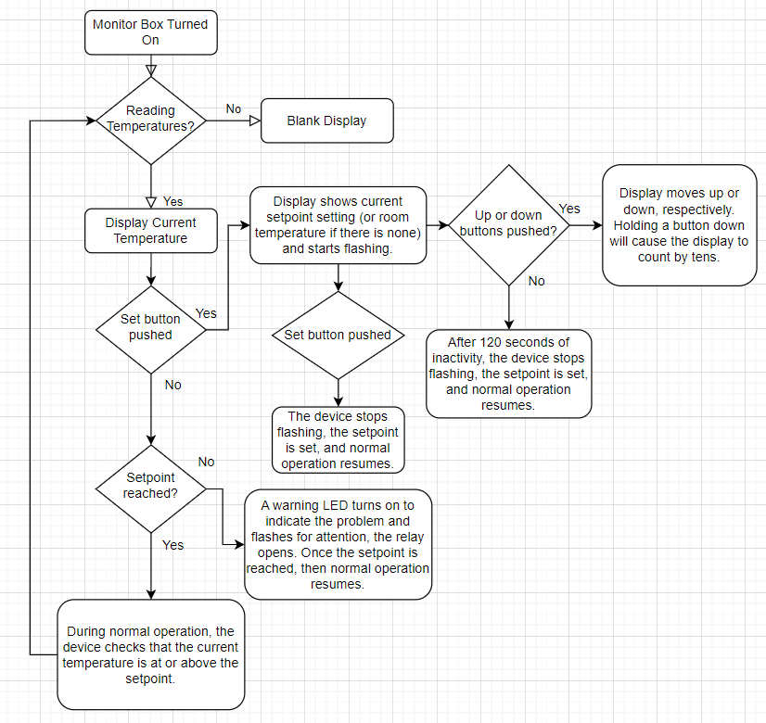
5.5. N.O. RELAY CIRCUIT
This is probably the most simple software module. If the monitor box is on but either cannot read temperatures or if the setpoint is violated, then a digital low signal will be applied to a digital output. If everything is normal, then a digital high signal will be output from the same GPIO.
The setpoint handling itself should have its own task where the current temperature is relayed to it every time it comes in via a queue. This task will be responsible for monitoring the temperature and will follow a state machine style architecture to handle the state of the relay. This task should also be responsible for storing the setpoint in non-volatile memory when it is selected, and for retrieving the last known setpoint on initialization.
5.6 NON VOLATILE MEMORY
There is a need for persistent memory in this project. The setpoint must be remembered between power cycles, and in order to implement a web server, there must be a file system to store web resources such as http files, javascript files, or css files. Not only that, but the network settings must be remembered between power cycles as well. In order to address this problem in the most cost effective way, this project will use an eMMC module. eMMC stands for embedded multi-media card. It is almost identical to an SD card but it is non removable and significantly less expensive.
On the prototype, the wiring for the project is exceedingly simple, given that an extension board for the ATSAM4S development board exists. The extension is the Ethernet1 Xplained Pro board and for the prototype, it plugs into EXT1, although it should be compatible on any of the boards extensions. (No wiring diagram needed).
6. CONCLUSION
This is the plan for the design of the software. There are still some lingering questions. Which modbus register should the current temperature reside at? What other variables would be good to make accessible via modbus? Should the web server be HTTP or HTTPS? HTTP would be faster, but obviously HTTPS is encrypted so it would be more secure. Is security of great importance here? Or is speed the priority?
There are other considerations concerning the hardware also. Technically, any CPU may be used for this project as long as it is in the ATSAM4S family. However, RAM must be considered. I would recommend to those developing the hardware to choose a CPU with no less than 128kB of RAM. The application will be developed using a CPU with 160kB so a CPU with that amount would be most likely to work successfully without additional troubleshooting.
One consideration is the eMMC module. For prototyping, an SD card and SD card reader will be used, but it would be ideal to be able to prototype with an eMMC module as well. When a module is selected, it is important that it is tested for compatibility with the software driver. It is the case that certain modules are compatible while others are not, depending on the interface that is used.
Also, the MAX31855 module is highly sensitive to stray capacitance so when designing the layout of the PCB, that must be considered, otherwise the temperature readings may not be very accurate. The way the chip reads temperature is based on voltages so it is essential that stray inductance or capacitance don’t disrupt those readings.
One more thing to add is that the buttons will be debounced entirely in software so there is no need to add any additional hardware for debouncing.

